HONG KONG INSTITUTE OF VOCATIONAL EDUCATION
Laboratory 2b: Initializer

TASK:
1. Estimate the output of the following code segment without using computer. Verify your result by using computer after you have finish it.
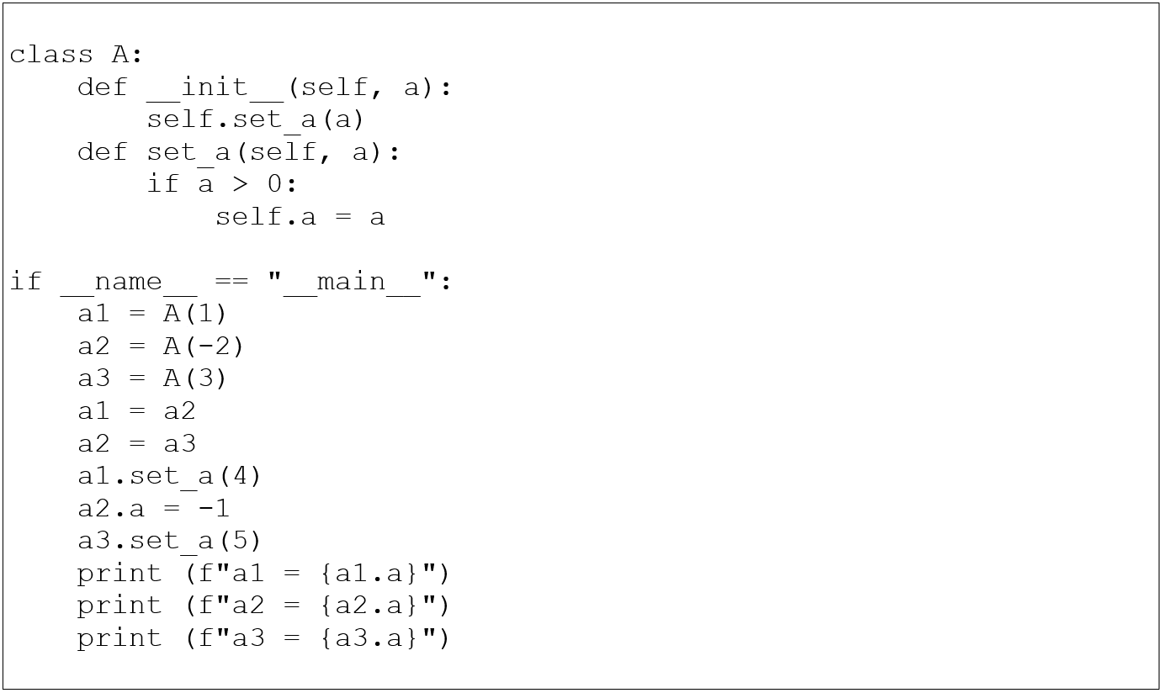
Estimated output:
a1 = 4
a2 = 5
a3 = 5
2. (a) Create a class Bread that has:
Bread
__name : str
__price : float
__total_quantity : int
__total_sales : float
__total_sales_no : int

__init__ (self, name, price)
get_name(self) : str
get_price (self) : float
get_quantity (self) : int
get_sales (self) : float
get_sales_no (self) : int
compute_sales (self, quantity) : float
Attributes:
name – to store the name of bread type
price – to store the price per bread
total_quantity – to store the total quantity sold
for this bread type
total_sales – to store the total sales for this
bread type
total_sales_no - to store the total number of
sales for this bread type
Methods:
__init__ – initialize the name and price
attributes.
initialize the attributes
total_quantity, total_sales,
total_sales_no to zero.f
get_name – return the name attribute of bread object in string format
get_price – return the price attribute of bread object in float format
get_quantity – return the total_quantity attribute of bread object in integer format
get_sales – return the total_sales attribute of bread object in float format
get_sales_no – return the total_sales_no attribute of bread object in float format
compute_sales – calculate the sales from price and quantity, accumulate the total number of sales by one, accumulate the sales and quantity to total_sales and total_quantity, and return the sales calculated in float format
Answer:
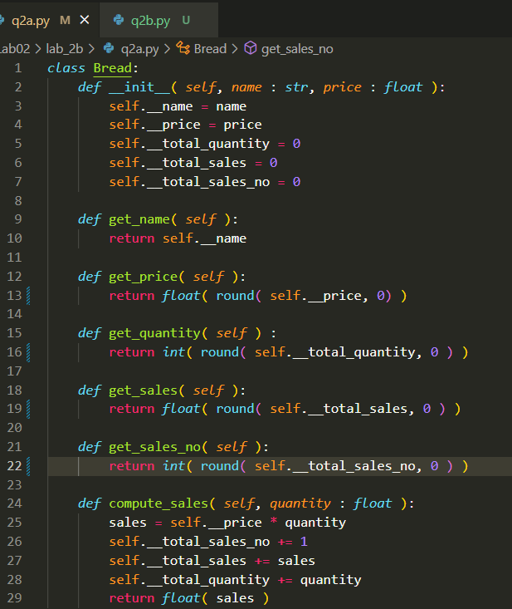
(b) Complete the following supplier class and client / driver program given
(i) Complete the statistics function to print price per bread, total quantity, total sales and total sales number.
(ii) Modify the part input quantity to validate user’s input when it is not a valid number.
(iii) Print the no. of pieces of bread, bread name and sales of current order with reference from sample output.

#function called by main program to display menu
def display_menu():
print("\nBakery Shop Menu:")
print(f"{'No':>2s}. | {'Bread Type':<15s} | "
f"{'Price':<4s}" )
for i in range ( len(list_bread) ):
print (f"{i:>2}. | "
f"{list_bread[i].get_name():<15s} | "
f"${list_bread[i].get_price()}")

#function called by main program to display statistics
def display_statistics():
print ("Statistics of Bakery Shop:")
# Print Bread Name
output_string = f"{'Bread Name':<20s}"
for i in list_bread:
output_string += f"| {i.get_name():<15s} "
print (output_string)
# Complete this part to print Price per Bread

# Complete this part to print Total Quantity

# Complete this part to print Total Sales

# Complete this part to print Total Sales Number

if __name__ == "__main__":
list_bread = list()
list_bread.append(Bread("French Toast",25))
list_bread.append(Bread("Cheese Loaf",30))
list_bread.append(Bread("Lemon Tart",20))
list_bread.append(Bread("Black Forest", 65))

print("Welcome to Bakery Shop System.")
display_menu()

while True:
while True:
try:
input_string=(f"Please input your choice."
f"(0 – {len(list_bread)-1}), "
f"s for statistics:")
input_result = input(input_string)
if input_result == "s":
display_statistics()
display_menu()
continue
input_bread_type = int(input_result)
if (input_bread_type < 0 or
input_bread_type >= len(list_bread)):
print ("Invalid input for choice")
continue
break
except:
print ("Invalid input for choice.")
# Modify the following part to validate
# user's input on quantity
input_quantity = int(input("Please input quantity:"))

selected_bread_type = list_bread[input_bread_type]
sales = selected_bread_type.compute_sales(input_quantity)
# Print the no. of pieces of bread, bread name and sales
# of current order with reference from sample output

Sample Output:
Welcome to Bakery Shop System.

Bakery Shop Menu:
No. | Bread Type | Price
0. | French Toast | $25
1. | Cheese Loaf | $30
2. | Lemon Tart | $20
User’s input
3. | Black Forest | $65
Please input your choice.(0 – 3), s for statistics:0
User’s input
Please input quantity:2
The price of 2 pieces of French Toast is 50
Please input your choice.(0 – 3), s for statistics:1
Please input quantity:3
The price of 3 pieces of Cheese Loaf is 90
Please input your choice.(0 – 3), s for statistics:2
User’s input
Please input quantity:5
The price of 5 pieces of Lemon Tart is 100
Please input your choice.(0 – 3), s for statistics:3
Please input quantity:7
The price of 7 pieces of Black Forest is 455
Please input your choice.(0 – 3), s for statistics:0
Please input quantity:2
User’s input
The price of 2 pieces of French Toast is 50
Please input your choice.(0 – 3), s for statistics:s
Statistics of Bakery Shop:
Bread Name | French Toast | Cheese Loaf | Lemon Tart | Black Forest
Price per Bread | 25 | 30 | 20 | 65
Total Quantity | 4 | 3 | 5 | 7
Total Sales | 100 | 90 | 100 | 455
Total Sales Number| 2 | 1 | 1 | 1

Bakery Shop Menu:
No. | Bread Type | Price
0. | French Toast | $25
1. | Cheese Loaf | $30
2. | Lemon Tart | $20
3. | Black Forest | $65
Please input your choice.(0 – 3), s for statistics:

Answer:

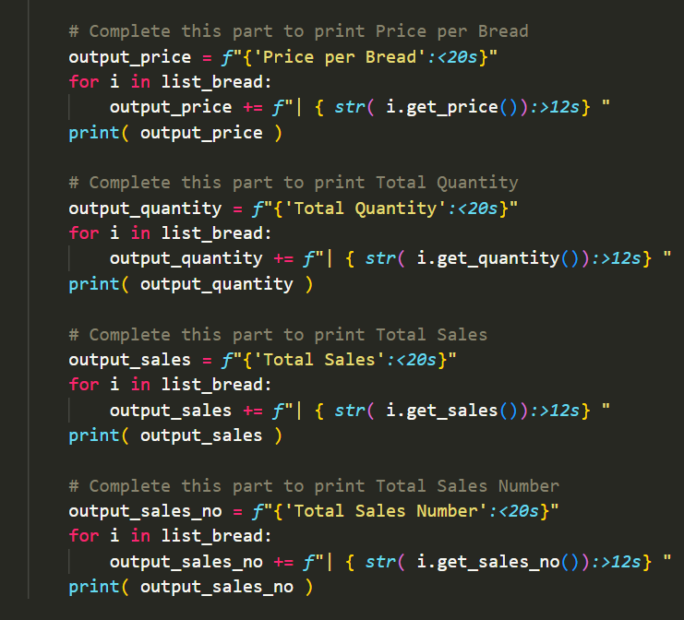

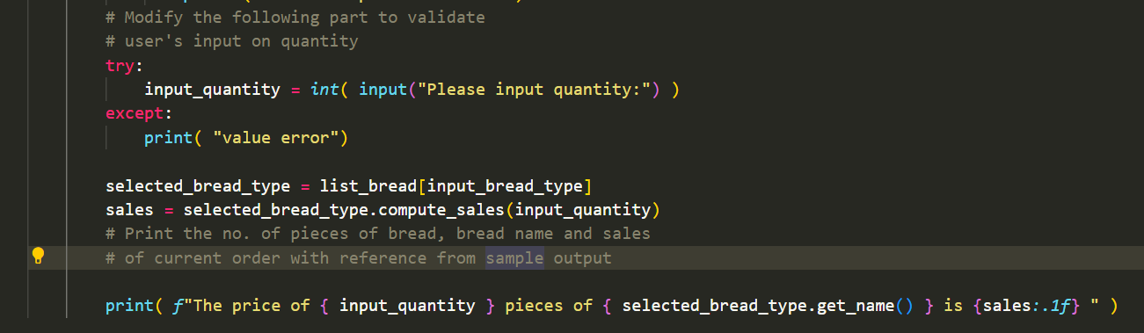

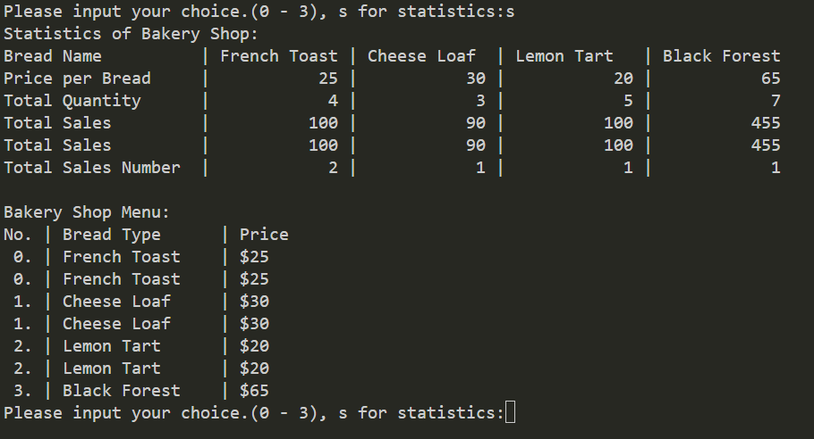

(c) Add additional breads into list_bread to test your program whether it supports more bread types
Answer:
